INTRODUCTION

Overview

**Exploring World’s Top YouTube Channels**

Purpose

YouTube channel is the Fantastic way to enhance of the visibility and it is the second largest search engine in the world

PROBLEM DEFINITION & DESIGN THINKING

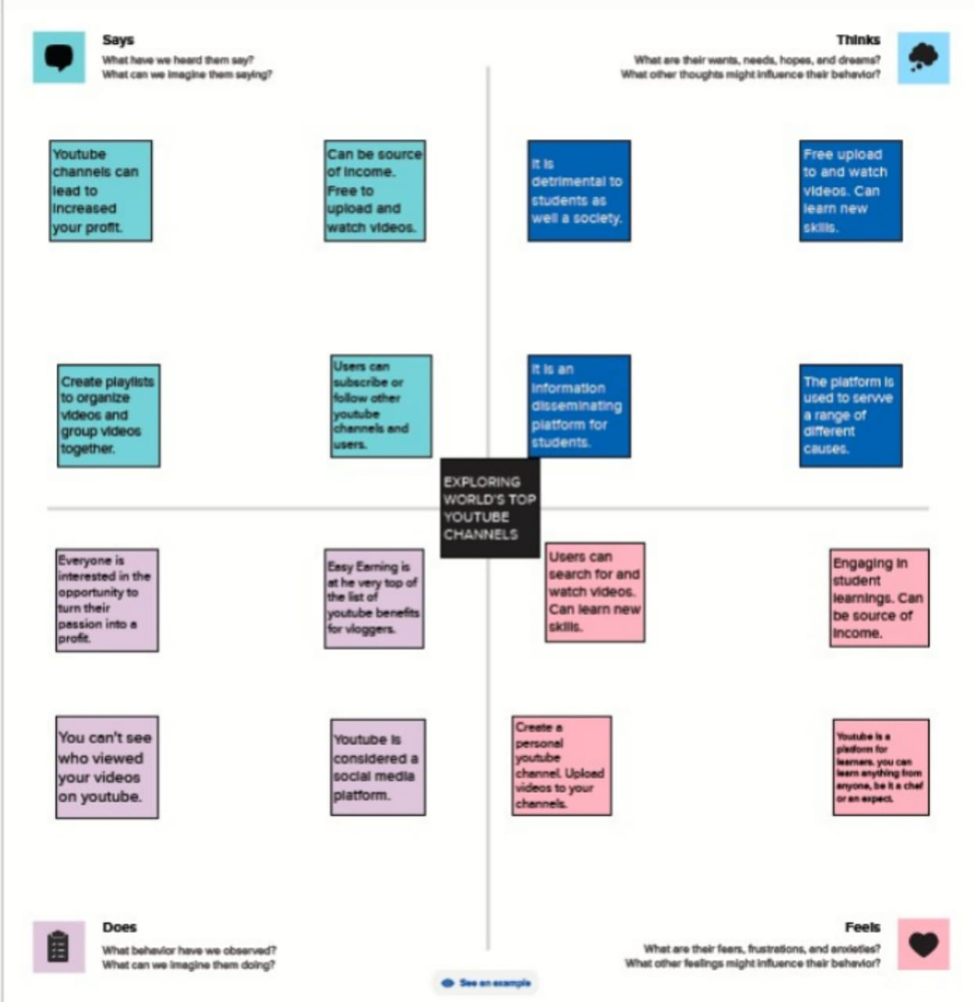 Empathy Map

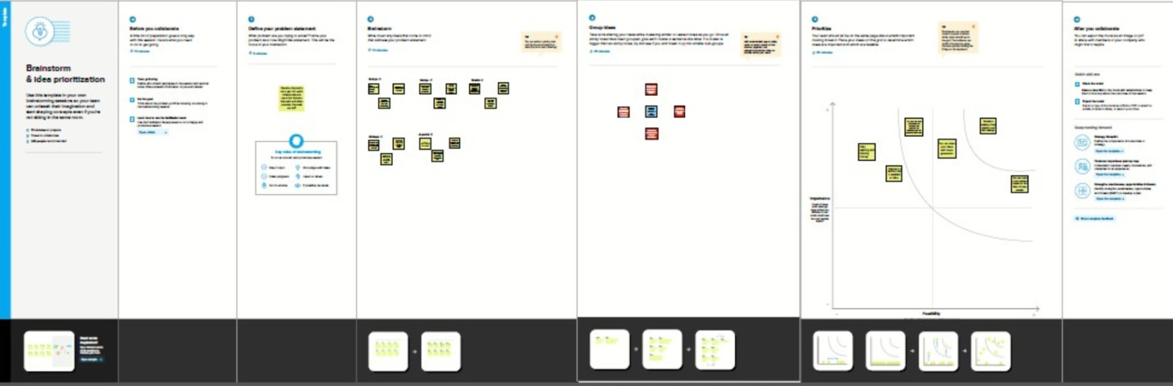 Ideation & Brainstorming Map

RESULT

Published Exploring World’s Top YouTube Channels. It include rank wise channel , country wise channel , brand and language wise subscribers

ADVANTAGE & DISADVANTAGES

Advantages

It is free of cost service and easy to use the service for good source to earn revenue. It can connect with a wide audience and also used by students for educational videos

Disadvantages

In YouTube channel there is a little difficult to start earning and also needs parental control setup. It is not easy to concentrate on a single topic

APPLICATIONS

It is important for the Educational purpose and also career objectives and enhancements to earn the money on the YouTube channels .YouTube channels is a social media platform and used by students

COCLUSION

Exploring world’s top YouTube channel are useful for the higher studies and get the knowledgeable information from it.

FUTURE SCOPE

The people upload more videos , shorts and also create more live stream daily. The people appealing content ID claims and eligible to apply for monetization